|  |
| --- |
| **[ 2ceit604 User experience design]** |
|  |

Practical: 1

**AIM- Learn about UI & UX with answering the following questions**



**Department of Computer Engineering/Information Technology**

1. **What is UI & UX?**

**UI:** The user interface is the graphical layout of an application. It consists of the buttons users click on, the text they read, the images, sliders, text entry fields, and all the rest of the items the user interacts with. This includes screen layout, transitions, interface animations and every single micro-interaction.

**UX:** A user’s experience of the app is determined by how they interact with it.

1. **Comparison of UI & UX.**

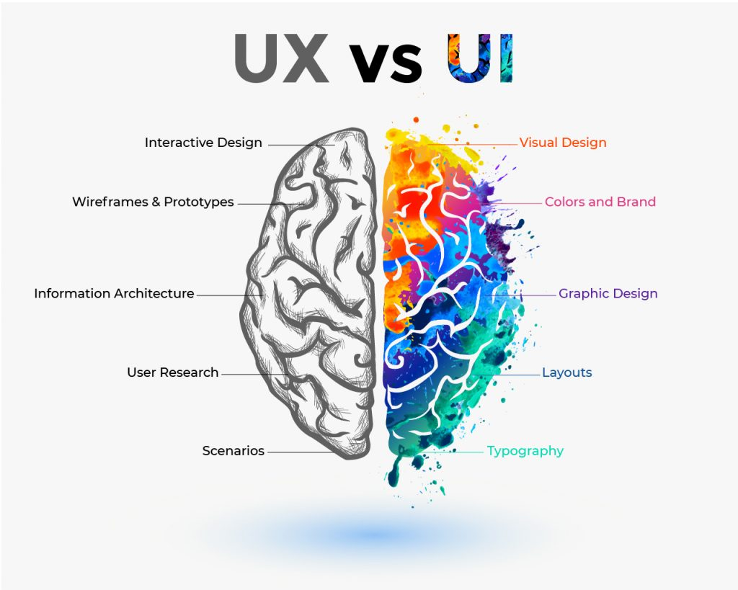

1. **List out qualities of UIUX design and demonstrate with an example.**

* Meet the User's Need.
* Hierarchy.
* Visibility of System Status.
* Match between System and the Real World.
* User Control and Freedom.
* Accessibility.
* Consistency and Standards..
* Recognition Rather than Recall
* Aesthetic and Minimalist design.
* **Flexibility and Efficiency of Use.**
* **Help and Documentation.**

**Example of UI :** Pinterest’s waterfall effect

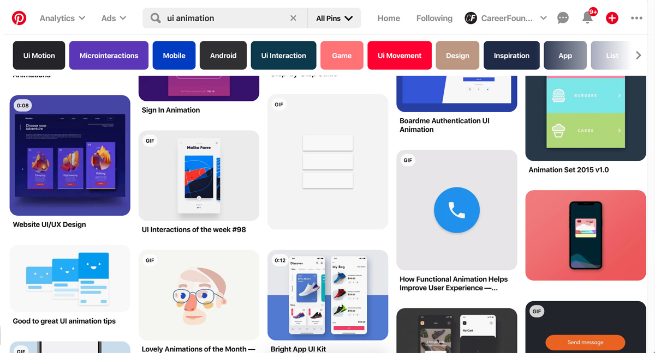

**Example of UX:** Airbnb's booking experience



1. **Explain 10 terms for UI & UX design**

### 4.1 Wireframe

A [wireframe](https://www.experienceux.co.uk/faqs/what-is-wireframing/) is a skeletal framework of your product, app, or website design. It is a blueprint of the design without any content, images, and interactive elements. The purpose of a wireframe is to lay out the functionality and content of the page, showing where a design element will be present on the screen.

### 4.2 Prototype

A [prototype](https://www.uxpin.com/studio/blog/what-is-a-prototype-a-guide-to-functional-ux/) is an outline of the proposed final product that is used for testing before launch. Low-level prototypes showcase a bare-bones sketch of how a design will look. High-level prototypes, on the other hand, add more details to the sketch, but aren’t full-design mockups.

### 4.3 Mockup

A [mockup](https://www.uxpin.com/studio/blog/what-is-a-mockup-the-final-layer-of-ui-design/) is a realistic representation of how the design will finally look in the end. Bear in mind that a mockup looks exactly like the final product. This means that it is formed after all the revisions to the design have been made.

### 4.4 A/B Testing

[A/B testing](https://mattish.com/evidence/method/a-b-tests) is also referred to as split testing. It is the process that asks users to pick from two versions of your design. The products are presented side by side to a group of users to learn which they like better.

### 4.5 Data-Driven Design

Design that is backed by data and helps understand the target audience better is known as [data-driven design](https://www.springboard.com/blog/data-driven-design/).

### 4.6 User Research

The process incorporates analytical tasks such as quantitative and qualitative research. Quantitative research relates to gathering numerical data to understand user behavior.

On the flip side, qualitative research is a descriptive attempt to understand the target audience’s problems, motivations, opinions, and reasons via processes such as interviews.

### 4.7 Interaction Design

[Interaction design](https://www.usability.gov/what-and-why/interaction-design.html) is a type of web design that is centered around creating an engaging interface with logical actions and behaviors. Successful interaction design is based on the use of technology and a clear understanding of good communication to create the desired user experience.

### 4.8 Usability Test

So, [usability testing](https://www.experienceux.co.uk/faqs/what-is-usability-testing/) asks users to complete tasks while a researcher observes them to learn about any problems or confusion encountered when interacting with the design.

### 4.9 Eye Tracking

As its name suggests, the method employs tools to track eye movements of the users to learn where they look at a design, website, or any other visual data.

### 4.10 Conversion Rate

Essentially, the conversion rate shows how effective your design is in convincing people to take action.